## WhatsApp Image 2022-11-07 at 9.31.00 PMADMIN DESIGN

Fig 6.2.1 Welcome Page.

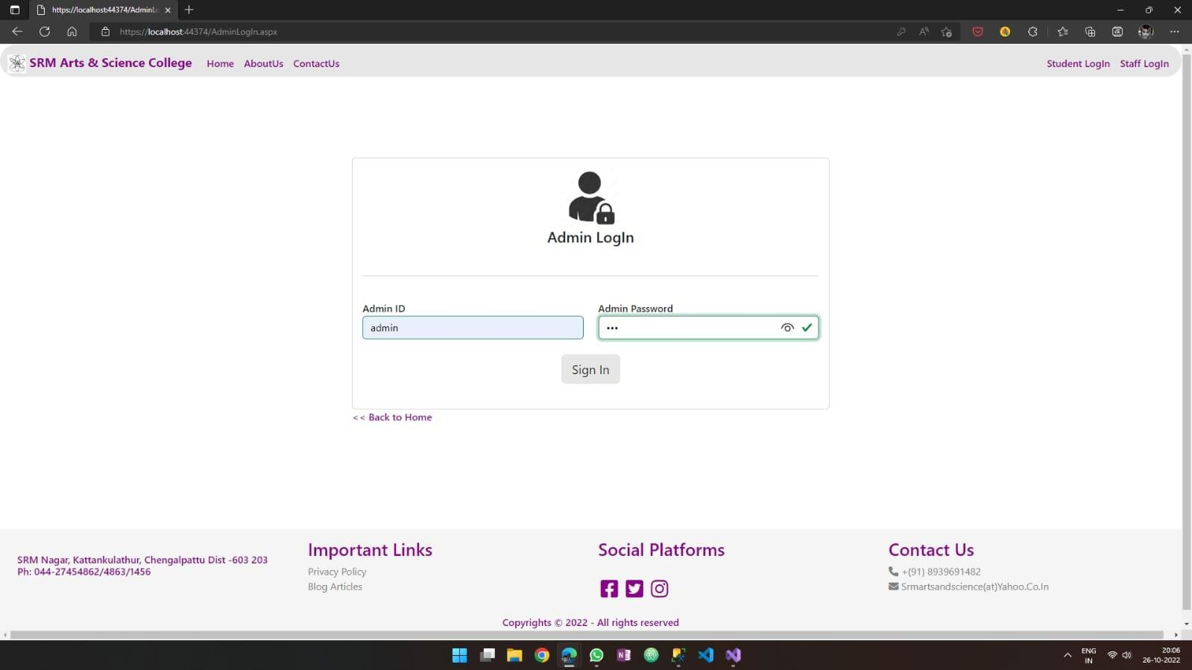

Fig 6.2.2 Admin login.

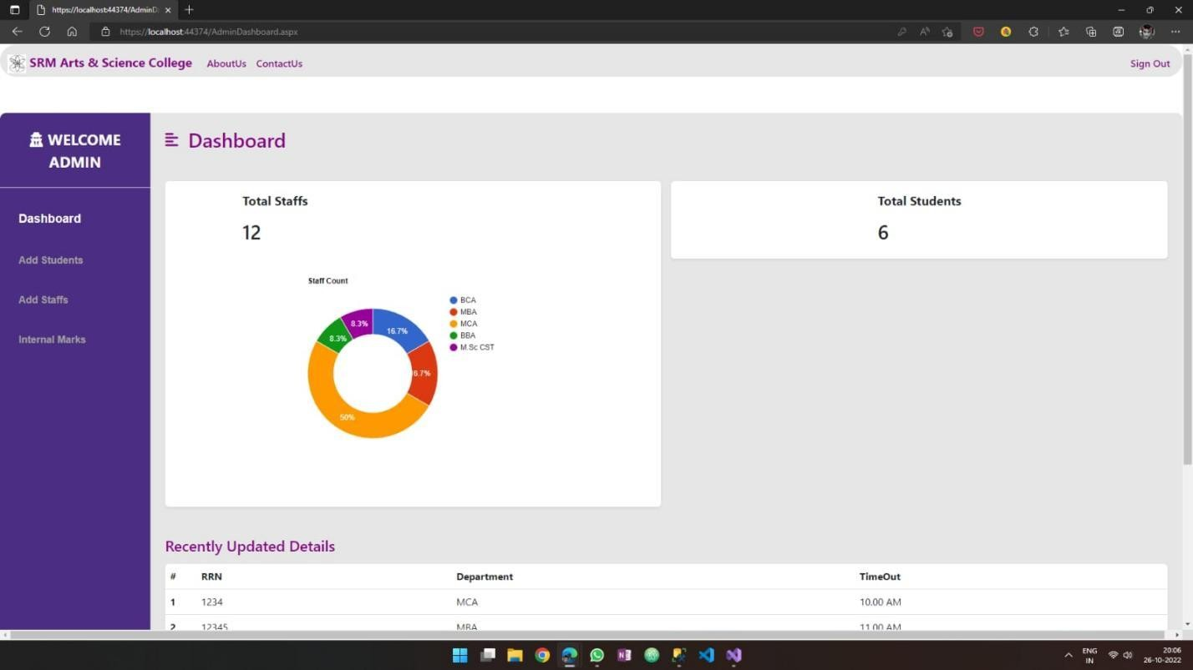

Fig 6.2.3 Admin Dashboard.

Fig 6.2.5 Result Analysis Page.